Reflection Questions about Movie “Race”

- What do you think of the movie? Anything that surprised you?
_____________________________________________________________________________________
_____________________________________________________________________________________
_____________________________________________________________________________________
_____________________________________________________________________________________
_____________________________________________________________________________________
_____________________________________________________________________________________
_____________________________________________________________________________________
_____________________________________________________________________________________
_____________________________________________________________________________________
_______________________________________________________________________________________________________________________________________________________________________________________________________________________________________________________________

- What are your reactions to how African Americans were portrayed and treated in the early 20th century?
_____________________________________________________________________________________
_____________________________________________________________________________________
_____________________________________________________________________________________
_____________________________________________________________________________________
_____________________________________________________________________________________
_____________________________________________________________________________________
_______________________________________________________________________________________________________________________________________________________________________________________________________________________________________________________________

- Give me at least three (3) examples that you found in the film that showcased racism and discrimination towards African Americans?
_____________________________________________________________________________________
_____________________________________________________________________________________
_____________________________________________________________________________________
_____________________________________________________________________________________
_____________________________________________________________________________________
_____________________________________________________________________________________
_____________________________________________________________________________________
_____________________________________________________________________________________
____________________________________________________________________________________________________________________________________________________________________________________________________________________________________________________________________________________________________________________________________________________
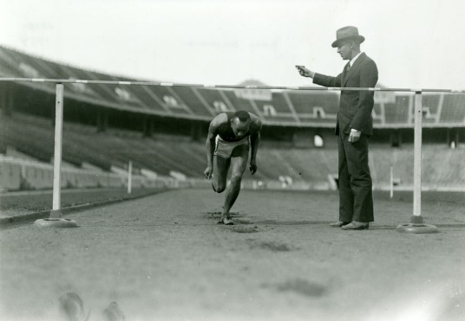
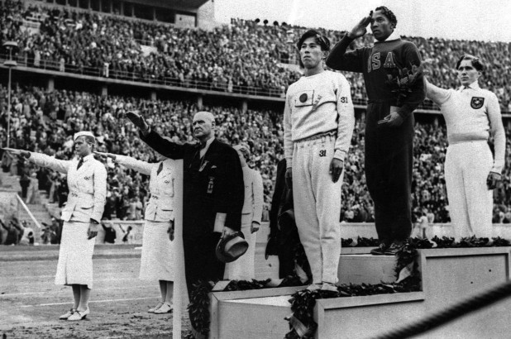
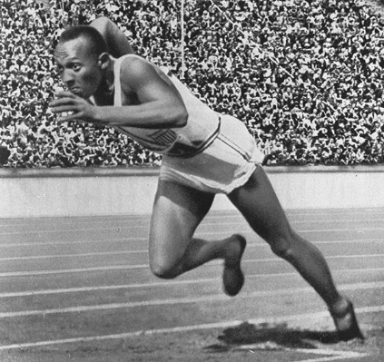

- How does the story of Jesse Owens promote the Olympic values of friendship, respect and excellence?
_____________________________________________________________________________________
_____________________________________________________________________________________
_____________________________________________________________________________________
_____________________________________________________________________________________
_____________________________________________________________________________________
_____________________________________________________________________________________
__________________________________________________________________________________________________________________________________________________________________________

- Hitler planned to use the Summer Olympics to prove his theories that “Aryans,” or white Europeans, were a superior race to all others.How did Jesse Owens accomplishments, as well as Kai Long’s (the German long jumper) actions anger the Germans and ruined their plans/vision?
_____________________________________________________________________________________
_____________________________________________________________________________________
_____________________________________________________________________________________
_____________________________________________________________________________________
_____________________________________________________________________________________
_____________________________________________________________________________________
__________________________________________________________________________________________________________________________________________________________________________

- With Europe being on the brink of war and with international tensions so high, why was it so important for Adolf Hitler to want the games filmed and broadcasted on television?
_____________________________________________________________________________________
_____________________________________________________________________________________
_____________________________________________________________________________________
_____________________________________________________________________________________
_____________________________________________________________________________________
_____________________________________________________________________________________
_______________________________________________________________________________________________________________________________________________________________________________________________________________________________________________________________

- In your opinion, would you characterize Jesse Owens as a hero to the American people? What about towards the African American community?
_____________________________________________________________________________________
_____________________________________________________________________________________
_____________________________________________________________________________________
_____________________________________________________________________________________
_________________________________________________________________________________________________________________________________________________________________________________________________________________________________________________________________________________________________________________________________________________________________________________________________________________________________________

